**CEMP – Centro Educacional Marapendi**

**Nome: _____________________________________________________ Data: __/10/2024**

**Professora: Márcia 6o Ano do Ensino Fundamental II**

**QUESTIONÁRIO DE GEOGRAFIA - Cap. 15 – Pág. 180 a 187**

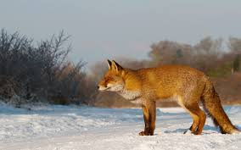

1. Observe a imagem abaixo e escreva o que se pede.

Cite um elemento biótico e um elemento abiótico visível.

_____________________________________________________________________________________

1. As vegetações podem ser classificadas em dois grupos de acordo com o porte da vegetação predominante na paisagem. O que isso significa?

_______________________________________________________________________________________________________________________________________________________________________________________________________________________________________________________________

1. 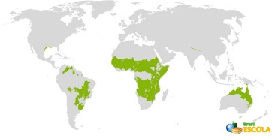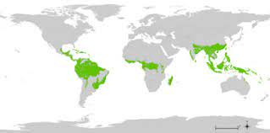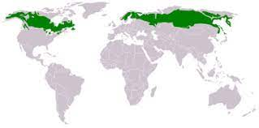Observe os mapas e identifique as formações vegetais características de cada uma das regiões retratadas.

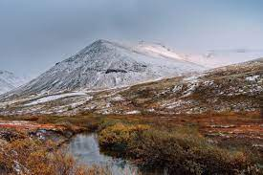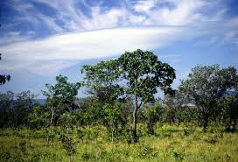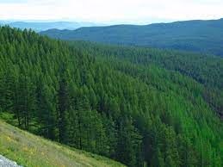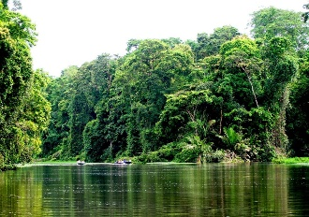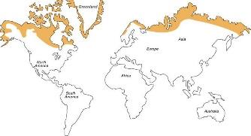

Agora escreva as características dessas vegetações.

______________________________________________________________________________________________________________________________________________________________________________________________________________________________________________________________________________________________________________________________________________________________________________________________________________________________________________________________________________________________________________________________