# CEMP – Ensino Médio

**Nome: _________________________________________________________________Data: / / 2024**

**Professor: Eliane 8°ano Ano do Ensino Fundamental Turma: _____**

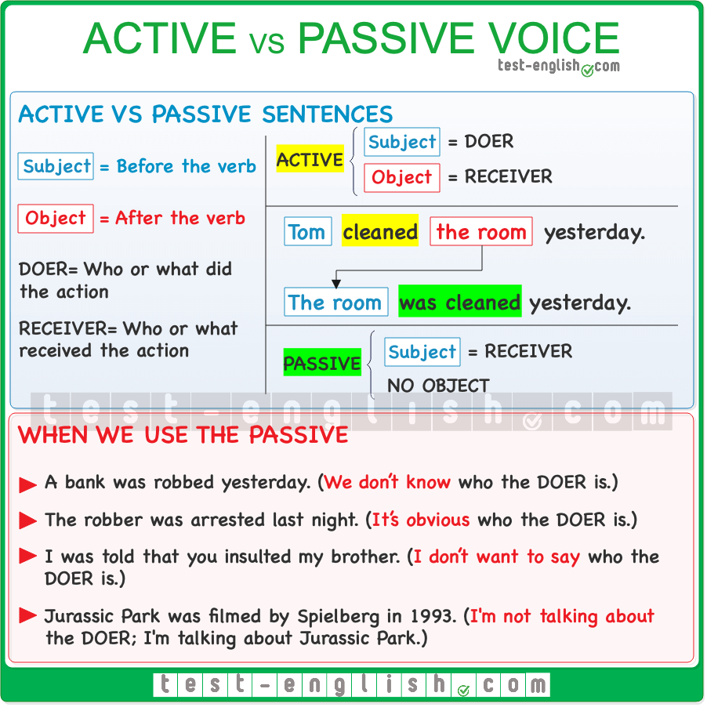

1. Rewrite the sentences in Passive voice.

Example:The cat chases the mouse.

Answer: The mouse is chased. Or The mouse is chased by the cat.

a) He writes emails.

The emails are written by him.

b) She **texted** Richard. Richard **was texted** by her.

c) We **study** English grammar. English grammar **is studied** by us.

d) The company **sells** products.\ Products **are sold** by the company.

____________________________________________________________  
e) My brother **visited** our grandparents.\ Our grandparents **were visited** by my brother.

____________________________________________________________  
f) The mechanic **fixes** the car engine.\ The car engine **is fixed** by the mechanic.

____________________________________________________________  
g) The artist **painted** a beautiful picture.\ A beautiful picture **was painted** by the artist.

____________________________________________________________

h) The waiter **serves** the customers.\ The customers **are served** by the waiter.

____________________________________________________________  
i) The police **caught** the thief.\ The thief **was caught** by the police .

____________________________________________________________  
j) The storm **damaged** the roof of the house.\ The roof of the house **was damaged** by the storm.

____________________________________________________________

2) Write in the box the right word.

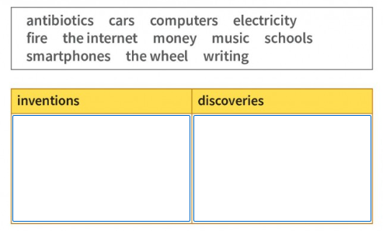

Discoveries : FIRE, ANTIBIOTICS, ELECTRICITY

3) Explain your choice using:

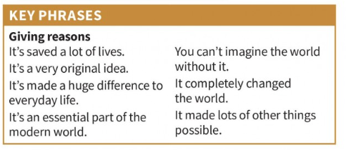

In my opinion, electricity is the most important INVENTION\ DISCOVERY because, FREE ANSWER.

4) Complete the blanks with: chorus,lyrics,melody,rhythm,single,songwriter, vocalist.

1. The **_songwriter__________**spent hours crafting the perfect__**_lyrics**________ to convey the emotions of the song.
2. The catchy **____melody _______** of the track made it a hit on the radio.
3. During the performance, the **_______vocalist_____** captured the audience's attention with her powerful voice.
4. The **____chorus______** was so memorable that everyone sang along at the concert.
5. The **__rhythm_______** of the beat kept everyone dancing all night long.
6. After weeks of work, the band finally released their latest **_____single___** to much anticipation.

5) Determine whether each sentence is in an active or passive voice.

1. The song was written by the talented songwriter. **__________PV**
2. The band played their new song at the concert.**__________AV**
3. The lyrics were memorized by the entire audience.**__________PV**
4. The vocalist sang the chorus with great emotion.**__________AV**
5. The latest single was produced by a famous label.**__________PV**

6) Complete with passive voice in the simple present.

1. The song **___________ is written** by the songwriter.
2. The lyrics **_________** **_are sung** by the vocalist.
3. The melody **__________ is played** by the band.
4. The concert **__________Is attended** by many fans.
5. The single **__________ is released** by the music label.

7) Complete with passive voice in the simple past.

1. The song **__________was written** by the songwriter.
2. The lyrics **__________were sung** by the vocalist.
3. The melody **__________was played** by the band.
4. The concert **__________ was attended** by many fans.
5. The single **__________** **was released** by the music label.