# EMP  Centro Educacional Marapendi

**Nome: ______________________________________________ Data: / /2024**

**Professor(a): Gabriela Nogueira 7 o Ano do Ensino Fundamental II Turma: _____**

**QUESTIONÁRIO 1 DE GEOGRAFIA PARA A PROVA 3º Bimestre**

1) Explique detalhadamente o ciclo do ouro.

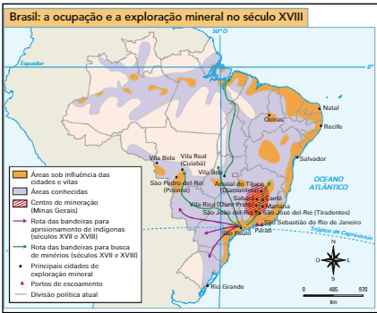

________________________________________________________________________________________________________________________________________________________________________________________________________________________________________________________________________________________________________________________________________________________________________________________________________________________________________________________________________________________________________________________________________________________________________________________________________________________________________________________________________________________________

2) Qual foi a importância do estabelecimento da Estrada Real para as cidades adjacentes naquela época

________________________________________________________________________________________________________________________________________________________________________________________________________________________________________________________________________________________________________________________

________________________________________________________________________________________________________________________________________________________________________________________________________________________________________________________________________________________________________________________

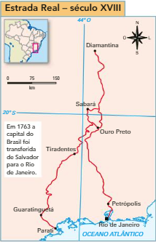

3) Defina os conceitos abaixo:

a) Tombamento ________________________________________________________________________________________________________________________________________________________________________________________________________________________________________________________________________________________________

b) Charque

________________________________________________________________________________________________________________________________________________________________________________________________

c) Terra roxa

________________________________________________________________________________________________________________________________________________________________________________________________

4) Crie um pequeno parágrafo falando sobre a atividade econômica do café.

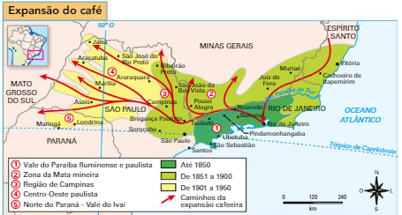

________________________________________________________________________________________________________________________________________________________________________________________________________________________________________________________________________________________________

________________________________________________________________________________________________________________________________________________________________________________________________________________________________________________________________________________________________

5) Cite três importâncias das ferrovias nessas atividades econômicas.

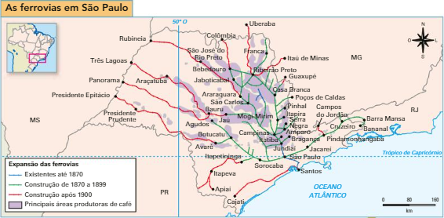

1. _____________________________________________________________________________________________
2. _____________________________________________________________________________________________

_____________________________________________________________________________________________